Name: Atiaro Bolade Emmanuel
Matric no: 241201091.
Department: Computer Science.
Course code: SEN 202.

Questionnaire Response Analysis

Introduction
A total of 30 respondents comprising students, staff, landlords, and security personnel participated in the survey. The questionnaire was designed to gather information on campus security challenges and to assess the need for the proposed Security Incident Mapping (SIM) web application.

Demographic Information

Table 4.1: Category of Respondents
Category | Frequency | Percentage (%)
Students | 18 | 60%
Academic Staff | 4 | 13%
Non-Academic Staff | 2 | 7%
Landlords | 4 | 13%
Security Personnel | 2 | 7%
Total | 30 | 100%

Analysis
The majority of respondents (60%) were students, indicating that students formed the largest group involved in the survey. This is expected since students are the primary users of the proposed SIM platform.

Experience with Campus Crime

Table 4.2: Have you witnessed a security incident on or around campus?
Response | Frequency | Percentage (%)
Yes | 23 | 77%
No | 7 | 23%
Total | 30 | 100%

Analysis
Most respondents (77%) indicated that they had witnessed at least one security incident on or around campus. This suggests that insecurity remains a significant concern within the campus environment.

Types of Security Incidents

Types of Incidents Witnessed
Incident Type | Frequency
Theft | 14
Assault | 6
Cultism | 4
Stabbing | 3
Rape | 2
Murder | 1

Analysis
Theft was identified as the most common security incident, followed by assault and cult-related activities. More serious crimes such as murder and rape were reported less frequently but remain major security concerns.

Common Locations of Crime

Table 4.4: Where do these incidents usually occur?
Location | Frequency
Student Hostels | 10
School Gate | 7
Isolated Roads | 5
Parking Area | 4
Lecture Halls | 2
Other Areas | 2

Analysis
Most security incidents occur around student hostels and the school gate, indicating that these areas require improved surveillance and security patrols.

Perception of Campus Safety

Table 4.5: How safe do you feel on campus?
Response | Frequency | Percentage (%)
Very Safe | 1 | 3%
Safe | 5 | 17%
Neutral | 8 | 27%
Unsafe | 12 | 40%
Very Unsafe | 4 | 13%

Analysis
More than half of the respondents (53%) considered the campus unsafe or very unsafe, highlighting the need for improved security measures.

Frequency of Security Incidents

Table 4.6: How often do security incidents occur?
Response | Frequency
Daily | 5
Weekly | 11
Monthly | 9
Rarely | 5

Analysis
Most respondents indicated that security incidents occur weekly or monthly, suggesting that crime is a recurring issue within the campus community.

Causes of Campus Insecurity

Table 4.7: Factors Contributing to Insecurity
Cause | Frequency
Poor Lighting | 22
Lack of CCTV Cameras | 20
Weak Security Patrol | 18
Slow Emergency Response | 16
Isolated Areas | 15
Lack of Awareness | 10
Suspicious Outsiders | 8

Analysis
Poor lighting, inadequate CCTV coverage, and weak security patrols were identified as the major causes of insecurity. These findings support the Ishikawa (Fishbone) analysis developed for this project.

Suggested Security Improvements

Table 4.8: Which should be improved first?
Improvement | Frequency
Install CCTV Cameras | 11
Improve Security Patrol | 8
Improve Campus Lighting | 6
Emergency Hotline | 3
Student Awareness Programmes | 2

Analysis
The majority of respondents recommended installing CCTV cameras and increasing security patrols as the highest priorities for improving campus security.

Acceptance of the SIM Platform

Table 4.9: Would you use the SIM web platform?
Response | Frequency | Percentage (%)
Yes | 27 | 90%
Maybe | 2 | 7%
No | 1 | 3%

Analysis
A significant majority (90%) expressed willingness to use the proposed Security Incident Mapping (SIM) system, indicating strong acceptance of the proposed solution.

Anonymous Reporting

Table 4.10: Should reports be anonymous?
Response | Frequency | Percentage (%)
Yes | 25 | 83%
No | 5 | 17%

Analysis
Most respondents preferred anonymous reporting, suggesting that anonymity may encourage more people to report incidents without fear of retaliation.

Preferred Notification Method

Table 4.11: Preferred Notification Method
Notification Method | Frequency
Mobile App Notifications | 12
SMS | 9
Email | 6
WhatsApp | 3

Analysis
Mobile notifications and SMS were the most preferred communication channels, indicating that users value immediate alerts during security incidents.

Effectiveness of the SIM System

Table 4.12: Do you think SIM will reduce campus crime?
Response | Frequency | Percentage (%)
Strongly Agree | 16 | 53%
Agree | 10 | 33%
Neutral | 3 | 10%
Disagree | 1 | 4%
Strongly Disagree | 0 | 0%

Analysis
Approximately 86% of respondents agreed or strongly agreed that the SIM platform would contribute to reducing campus crime. This demonstrates strong confidence in the proposed system's potential to improve campus safety.

Summary of Findings
The survey findings reveal that campus insecurity remains a major concern among students, staff, landlords, and security personnel. Theft, assault, and cult-related activities were identified as the most common crimes, with student hostels and school gates being the most affected locations. Respondents identified poor lighting, lack of CCTV cameras, and inadequate security patrols as the leading causes of insecurity. Furthermore, there was strong support for the proposed Security Incident Mapping (SIM) platform, with 90% of respondents indicating they would use the system and 86% believing it would help reduce crime. These findings justify the development of the SIM web application as a practical solution for improving incident reporting, emergency response, and overall campus security.

Ishikawa diagram

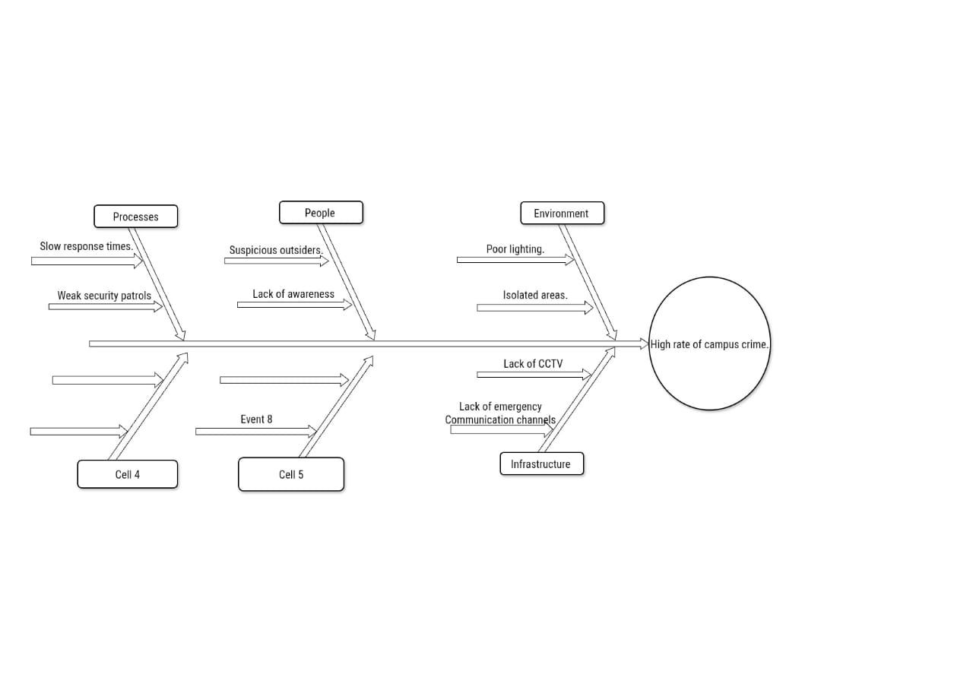

Security Index Mapping website

<!DOCTYPE html>

<html lang="en">

<head>

<meta charset="UTF-8">

<meta name="viewport" content="width=device-width, initial-scale=1.0">

<title>SIM - Security Incident Mapping</title>

<style>

body{

font-family: Arial, sans-serif;

background:#f4f4f4;

margin:0;

}

header{

background:#003366;

color:white;

text-align:center;

padding:20px;

}

.container{

width:60%;

margin:20px auto;

background:white;

padding:20px;

border-radius:8px;

box-shadow:0 0 10px rgba(0,0,0,0.2);

}

input, select, textarea{

width:100%;

padding:10px;

margin:8px 0;

}

button{

background:#007bff;

color:white;

border:none;

padding:12px 20px;

cursor:pointer;

}

button:hover{

background:#0056b3;

}

.alerts{

margin-top:30px;

background:#ffeeba;

padding:15px;

border-radius:5px;

}

</style>

</head>

<body>

<header>

<h1>Security Incident Mapping (SIM)</h1>

<p>Report Campus Security Incidents</p>

</header>

<div class="container">

<h2>Report an Incident</h2>

<form id="incidentForm">

<label>Full Name</label>

<input type="text" id="name" required>

<label>Your Role</label>

<select id="role">

<option>Student</option>

<option>Staff</option>

<option>Landlord</option>

</select>

<label>Incident Type</label>

<select id="incident">

<option>Theft</option>

<option>Stabbing</option>

<option>Assault</option>

<option>Rape</option>

<option>Murder</option>

<option>Cultism</option>

<option>Other</option>

</select>

<label>Location</label>

<input type="text" id="location" required>

<label>Description</label>

<textarea id="description" rows="4"></textarea>

<button type="submit">Submit Report</button>

</form>

<div class="alerts">

<h3>Recent Security Alerts</h3>

<ul>

<li>Theft reported near Hostel A</li>

<li>Suspicious activity at School Gate</li>

<li>Assault reported near Library</li>

</ul>

</div>

</div>

<script>

document.getElementById("incidentForm").addEventListener("submit", function(event){

event.preventDefault();

let name = document.getElementById("name").value;

let incident = document.getElementById("incident").value;

let location = document.getElementById("location").value;

alert(

"Thank you, " + name +

"!\n\nYour " + incident +

" report at " + location +

" has been submitted successfully."

);

this.reset();

});

</script>

</body>

</html>

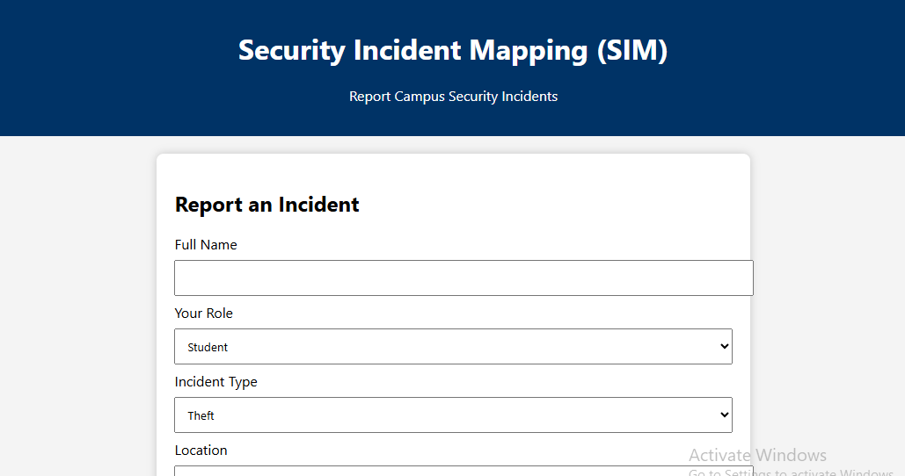
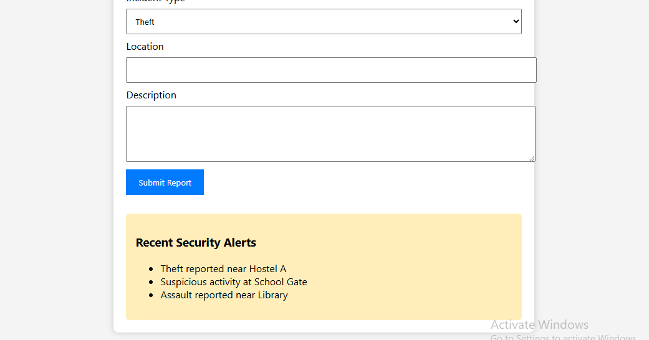

- Use case diagram:

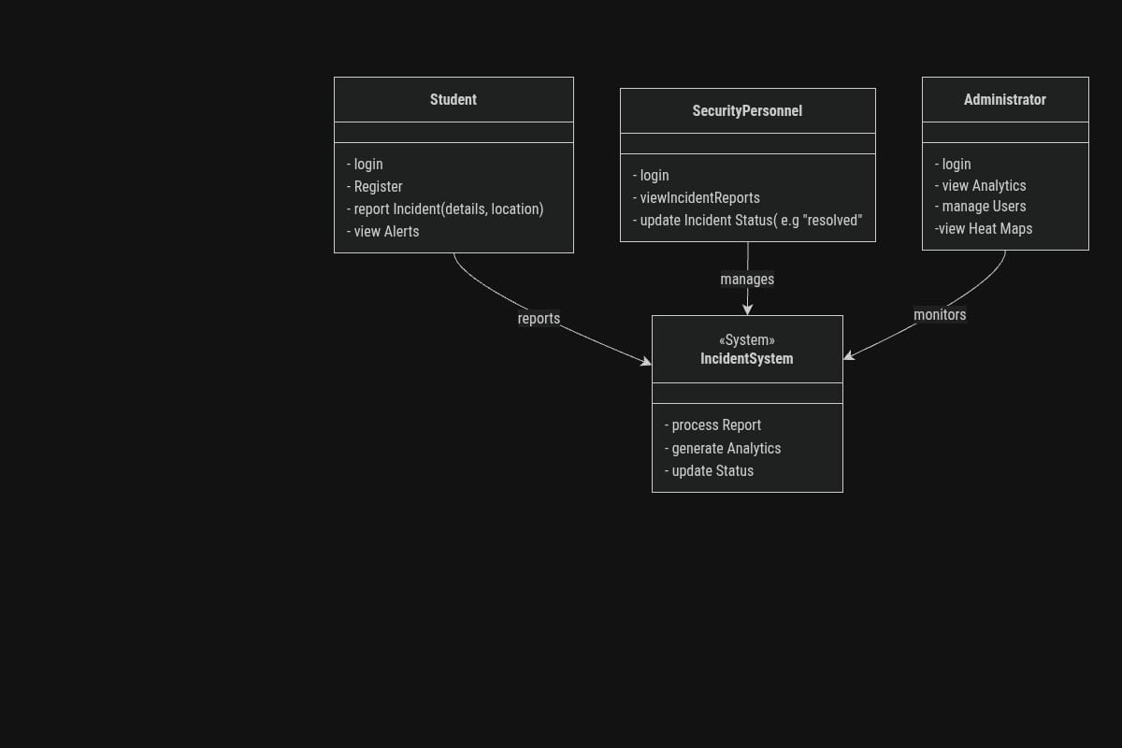

SOFTWARE REQUIREMENTS SPECIFICATION (SRS)
SIM (Security Incident Mapping System)

Introduction

Purpose
The purpose of the Security Incident Mapping (SIM) system is to provide students, staff, landlords, and security personnel with a web-based platform for reporting and monitoring security incidents occurring on and around campus. The system aims to improve emergency response time, increase security awareness, and support crime analysis through incident mapping.

Scope
The SIM system enables users to:
- Register and log into the platform.
- Report security incidents with location details.
- Upload descriptions and evidence (where applicable).
- View security alerts.
- Allow security personnel to update incident status.
- Allow administrators to manage users and monitor crime trends using analytics and heat maps.

Overall Description

Users
- Students
- Academic Staff
- Non-Academic Staff
- Landlords/Landladies
- Security Personnel
- System Administrator

Major Components

Student Module
- Registration
- Login
- Incident Reporting
- View Alerts

Security Personnel Module
- Login
- View Incident Reports
- Update Incident Status
- Respond to Emergencies

Administrator Module
- Login
- Manage Users
- View Reports
- View Crime Analytics
- View Heat Maps

Database
Stores:
- User Accounts
- Incident Reports
- Locations
- Crime Categories
- Incident Status
- Alerts

3. Functional Requirements
The SIM system shall:

Functional Requirement 1: Allow users to register.

Functional Requirement 2: Allow registered users to log in securely.

Functional Requirement 3: Allow students and residents to report incidents.

Functional Requirement 4: Capture:
- Incident Type
- Description
- Date
- Time
- Location
- Reporter Information

Functional Requirement 5: Allow photo uploads (optional).

Functional Requirement 6: Display security alerts.

Functional Requirement 7: Allow security personnel to:
- View reports
- Update report status
- Mark incidents as resolved

Functional Requirement 8: Allow administrators to:
- Manage users
- Delete false reports
- Generate analytics
- Monitor crime hotspots

Functional Requirement 9: Store all reports securely in a database.
Functional Requirement 10: Generate reports for crime analysis.

4. Non-Functional Requirements

Performance
- Reports should be submitted within 5 seconds.
- Dashboard should load within 3 seconds.

Security
- Secure login.
- Password encryption.
- Role-based access.
- Data confidentiality.

Reliability
- System availability of at least 99%.
- Automatic database backup.

Usability
- User-friendly interface.
- Responsive design for mobile and desktop.
- Easy navigation.

Maintainability
- Modular architecture.
- Easy software updates.

Scalability
- Support increasing numbers of users and incident reports without significant performance degradation.

Availability
- Accessible 24 hours a day.

Compatibility
- Compatible with Chrome, Firefox, Edge, Safari, and mobile browsers.

5. System Interaction
Students/Landlords/Staff
→ Register/Login → Report Incident → System Stores Report → Security Personnel Receive Notification → Update Status → Administrator Monitors Analytics and Heat Maps.

6. Constraints
- Internet connection required.
- Users must have valid accounts to access protected features.
- Administrators have the highest level of system privileges.

7. Assumptions
- Users provide accurate incident information.
- Security personnel respond promptly to reported incidents.
- The institution maintains the system infrastructure and database.

